1. Introduction

The city of Barcelona is one of the most visited cities in the world. It is a large city with many robust neighborhoods and areas of interest. For a traveler to the city, it can be difficult to maximize one's time and see the great things the city has to offer. In order to provide the best possible experience in the city, we will compare different neighborhoods within the city to determine an optimal vacation. A traveler can use the information to determine which neighborhood to stay in based on things like food, shopping, nightlife, and attractions.

1. Data

In this project, we will use Foursquare to identify the must-do items in Barcelona. A user will be able to determine where to go in each neighborhood, what are some of the must-see attractions in the city, and where the best places to eat are. K-means clustering will be used to compare different neighborhoods within the city.

Foursquare is a technology company that uses location intelligence to build meaningful consumer experiences and business solutions. We will use location data to find recommendations in different neighborhoods of Barcelona.

Each neighborhood is defined as a district. The geospatial JSON file will be used to determine the latitude and longitude of each district. A call to the Foursquare API will get information for each of the different districts. K-means clustering will be used to examine the differences between neighborhoods.

1. Methodology

The city of Barcelona is split up into 10 districts. The geospatial data for each neighborhood was obtained online and read into python using ‘read_csv’ from pandas. A call to the Foursquare API was applied to obtain venue information for each district. K-means clustering was used to cluster different districts and view the top venues within each one. They Folium package was used to create cluster maps of the different districts

1. Results

After reviewing the different districts and clusters, a traveler can see that the districts in the third cluster provide the most things to do and see.

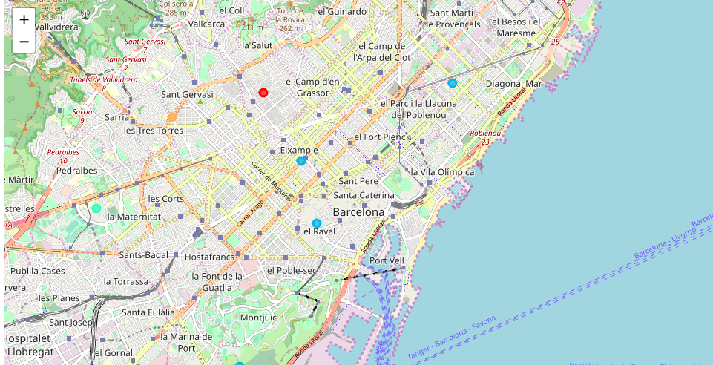

.

1. Discussion

By reviewing different districts in Barcelona, a traveler can optimize his stay and experience the best the city has to offer. The third cluster of districts has many food and drink places to experience the local flavor of the city. The traveler can use the maps and programs to create an itinerary that is unique and localized. The top activities in each district are immediately available and will reduce the efforts of the traveler.

1. Conclusion

The different districts of Barcelona can make it difficult for a traveler to know how to best experience the wonderful city. Our analyses has eased the burden of the traveler and optimized the travel experience.